Outcome 1 – Describe programming and testing methods.
1.1 Describe structured programming constructs.
Programming constructs: Expression, Sequence, Selection, Iteration, Predefined Function & File Handling.
Expression: in a programming language is a combination of one or more explicit values, constants, variables, operators and functions that the programming language interprets (according to its particular rules of precedence and of association) and computes to produce (‘to return”, in a stateful environment) another value. This process, as for mathematical expressions, is called evaluation.
Sequencing: This mean that the computer will run your code in order, one line at a time from the top to the bottom of your program. It will start at line 1, and then executes line 2 then 3, and so on till it reaches the last line of your program.
Selection: Sometimes you only want some lines of code to be run only if a condition is met, otherwise you want the computer to ignore these lines and jump over them. This is achieved using IF statements.
Iteration: Sometimes you want the computer to execute the same lines of code several times. This is done using a loop. There are three types of loop; for loops, while loops and repeat until loops. That’s handy as it enables you to copy the same lines of code many times.
Predefined Function: Any set of subroutines that perform standard mathematical functions included in a programming language; either included in a program at compilation time, or when called when a program is executed.
File Handling: Early arcade machines stored your high scores, but as soon as the machine is turned off then the scores are wiped. Writing files allows people to save scores, trophies etc. alongside all other essential file writing such as text documents, music and images. Another use of files is reading data to your program, think about loading a saved game, or opening a spreadsheet – both involve file reading.

  - Describe simple data types, data structures and algorithms.
Data Types: String, integer, Float, Boolean.
Data Structures: Array, Hashes etc.
Algorithms: ‘Simple’ algorithms are; linear search, input validation, find maximum, find minimum and count occurrences.
Binary Search: Binary search is an efficient algorithm for finding an item from an ordered list of items. It works by repeatedly dividing in half the portion of the list that could contain the item, until you've narrowed down the possible locations to just one. We used binary search in the guessing game in the introductory tutorial.
Insertion Sort: Loops over positions in an array, starting with index 1. Each new position is like a new card being dealt to by a dealer; you need to insert it into the correct place in the sorted subarray to the left of that position.
Recursive Sort: An algorithm to solve a problem by solving a smaller instance of the same problem, unless the problem is so small that we can just solve it directly. We call this technique recursion.
Merge Sort: This method divides-and-conquers; breaks a problem into sub-problems that are similar to the original problem, recursively solves the sub-problems, and finally combines the solutions to the sub-problems to solve the original problem. Because divide-and-conquer solves sub-problems recursively, each sub-problem must be smaller than the original problem, and there must be a base case for sub-problems.
Algorithm Question Example: State the purpose of this algorithm, describe what it does and what will be returned when it is run –
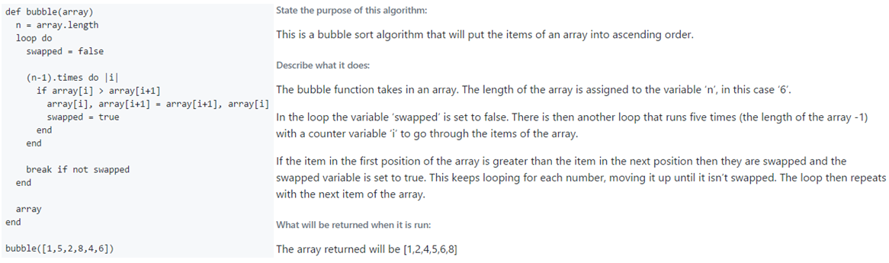

1.3 Describe basic software testing methods.
Software testing methods: Static Testing, Dynamic Testing, White Box Testing & Black Box Testing.
Static Testing: A testing technique in which the software is tested without executing the code. Can find such errors as; variable with an undefined value, variables that are declared but never used, unreachable/dead code & syntax violations.
Dynamic Testing: A kind of software testing technique using which the dynamic behaviour of the code is analysed. Dynamic testing involves testing the software for the input values and output values are analysed. Dynamic testing is the Validation part of Verification and Validation. Various levels of Dynamic testing; Unit testing, Integration testing, System testing & Accepting testing.
Black Box vs. White Box Testing:
Black Box: Also known as functional testing treats software under test without knowing its internals. Interfaces are used; as long as these remain unchanged tests will pass even if the internals are changed. It provides external perspective of the software under test.
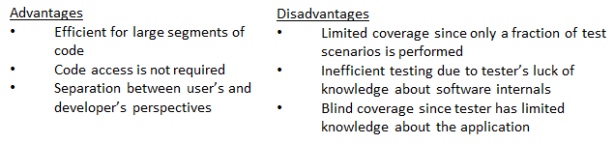
White Box: Also known as clear box, glass box, transparent box and structural testing. Looks inside the software being testing and uses that knowledge as part of the testing program. It requires internal knowledge of the system/program and provides internal perspective of the software under test.
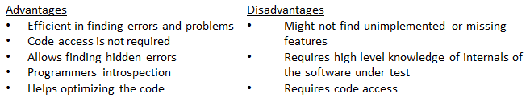

Software testing methods: Unit Testing, Integration testing, Component testing & System testing.
Unit Testing: Individual units/components of a software/system are tested. The purpose is to validate that each unit of the software performs as designed.
Integration Testing: Individual units are combined and tested as a group. The purpose of this level of testing is to expose faults in the interaction between integrated units.
System Testing: A complete, integrated system/software is tested. The purpose of this test is to evaluate the system’s compliance with the specified requirements.
Acceptance Testing: a system is tested for acceptability. The purpose of this test is to evaluate the system’s compliance with the business requirements and assess whether it is acceptable for delivery.
Component Testing: is that in which we test those test objects which are separately testable as a isolated unit without integrating with other components (e.g. modules, programs, objects, classes, etc.).
Normal/Extreme/Exceptional Test Data:
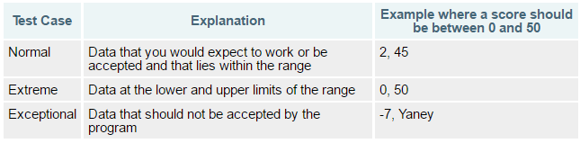
Syntax Error: misspelling a key word e.g. pint instead of print. Missing a character that is needed e.g. missing a bracket or speech marks.
Execution Error: an error that occurs when the program is running. Normally caused by trying to divide a value by 0, of trying to open a text file that doesn’t exist.
Logic Error: sequencing errors where a line of code is correctly formed but in the wrong place. Errors in calculations e.g. subtracting instead of adding. Errors when checking conditions, for example using <= instead of <.
Dry Run: A dry run is the process of a programmer manually working through their code to trace the value of variables. There is no software involved in this process – used to identify logic errors, will not find execution errors.
Walkthroughs: has one or two broad objectives: to gain feedback about the technical quality or content of the document; and/or to familiarize the audience with the content.
Breakpoints: A breakpoint is a point in the program where the code will stop executing. When a breakpoint is set and triggered the program will display the value of the variables at that point only.
Trace Tables: Trace tables are used to allow programmers to trace the value of variables as each line of code is executed. The values of the variables are displayed in a table and assist the programmer in identifying any potential errors.
Internal Commentary: lets a programmer add comments to their code that will not be translated when the program runs. Makes it easier to see what is going on in your program. If you are looking at someone else's code, it can save you time instead of having to work out what each line of code is doing.
Meaningful Identifiers: Making sure you use variable names that describe what the variable contains is very important. Poor variable names can make it difficult to work out what is going on in your program. Bland names such as ‘function2’ or ‘data’ are poor naming conventions.
Indentation: It's easier to see the overall structure of the code. Using indentation can make your code much easier to read. Often when debugging proper indentation of your code will show up an error.
1.4 - Describe contemporary programming paradigms.
Object-orientated programming: (OOP) is a programming language model organized around objects rather than "actions" and data rather than logic. Historically, a program has been viewed as a logical procedure that takes input data, processes it, and produces output data.
Event Driven Programming: in which the flow of the program is determined by events such as user actions (mouse clicks, key presses), sensor outputs, or messages from other programs/threads.
Procedural Programming: Procedures, also known as routines, subroutines, or functions simply contain a series of computational steps to be carried out. Any given procedure might be called at any point during a program's execution, including by other procedures or itself.

